
Reach out to all
Embrace His Gifts
Announce His coming
Commit to Christian Living
Honor His Word
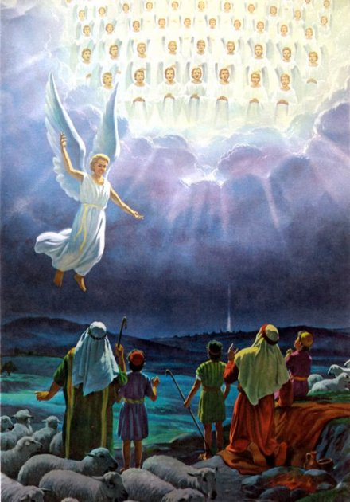

St. Peter’s Evangelical Lutheran Church
Pastor Ron Moritz, Deacon Ed Smallcombe
Christmas Eve, 2025

Pastoral Welcome
Invocation C: Amen
P: I will go to the altar of God,
C: to God my exceeding joy.
P: Our help is in the name of the Lord,
C: Who made heaven and earth.
P: Let us now confess our sins to God, our Father.
(You may kneel or sit) P: Most merciful God,
All: we confess that we are by nature sinful and unclean. We have sinned against You in thought, word, and deed, by what we have done and by what we have left undone. We have not loved you with our whole heart; we have not loved our neighbors as ourselves. We justly deserve Your present and eternal punishment. For the sake of Your Son, Jesus Christ, have mercy on us. Forgive us, renew us, and lead up, so the we may delight in Your will and walk in Your ways to the glory of Your holy name, Amen,
P: Announcement of God’s Forgiveness
We invite all worshippers to share the ‘Christmas Peace of Christ’ with those near us
(We return to our seats to sing)
HYMN #379 “O Come All Ye Faithful” vs 1 & 4
P: For unto us a child is born,
C: Unto us a son is given..

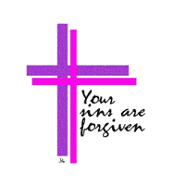

HYMN #379 “O Come All Ye Faithful” vs 1 & 4
P: For unto us a child is born,
C: Unto us a son is given
P: And the government shall be upon his shoulders,
C: And he will be called:
All: Wonderful Counselor, Mighty God, Everlasting Father! The Prince of Peace!
P: Of the increase of his government and peace,
C: There will be no end.
P: He will reign on David’s throne,
C: and over his kingdom.
P: establishing it and upholding it,
C: with justice and righteousness
P: From that time on and forever,
All: The zeal of the Lord Almighty will accomplish this.
OMMUNION
COLLECT FOR CHRISTMAS EVE
HYMN: # 361 “O Little Town of Bethlehem” vs 1
Reading from Luke 2
First Reading vs 1-7
HYMN: # 374 “Gentle Mary Laid Her Child” vs 1
Second Reading vs 8-14
HYMN # 368 “Angels We Have Heard On High” vs 1 & 3
Third Reading vs 15-20
HYMN # 364 “Away In A Manger
Christmas Eve Homily
Christmas Eve Offering is Dedicated at the Altar as we sing:
HYMN# 390 “Let Us All with Gladsome Voice”
(We stand for the communion liturgy)
P: The Lord be with you
C: And also with you
P: Lift up your hearts
C: We lift them to the Lord
P: Let us give thanks to the Lord, our God
C: It is right to give Him thanks and praise
P: Therefore, with angels and arch angels and all the company of heaven we laud and magnify Your glorious Name evermore praising You and singing:
HYMN# 386 “Now Sing We, Now Rejoice” vs 1
P: Prayer pf Thanksgiving
P: Lord remember us in Your kingdom and teach us to sing
All: LORD”S PRAYER (sung)

COMMUNION
WORDS OF INSTITUTION

P: The peace of the Lord be with you always
C: And also with you

Pastor communes those using individual communion packs. The remainder of the congregation communes at the rail in traditional manner

Common Dismissal and Post Communion Prayer
Following the prayer we will light our candles and the lights are dimmed

P: “Arise, Shine for you Light has come and the glory of the Lord has risen upon you. Nations shall come to your Light”
Jesus said: “I am the Light of the World, he who follows me will not walk in darkness but will have the light of life.”
“You are the light of the world...Let your light so shine before men, that they may see your good works and give glory to your Father in heaven.”

Congregation sings: “Silent Night” (see page 5)

Benediction

C: Amen (Candles are turned off)

Closing HYMN: # 387 “Joy to the World” vs 1 & 4
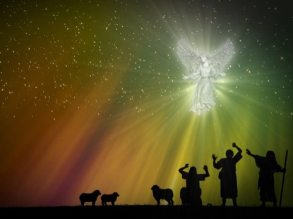

1. Silent Night, Holy Night! All is calm, all is bright
Round yon virgins mother and child. Holy Infant so tender and mild, Sleep in heavenly peace, Sleep in heavenly peace.

2. Silent Night, Holy Night! Shepherds quake at the sight;
Glories stream from heaven a far, Heavenly hosts sing Alleluia!
Christ the Savior is born! Christ the Savior is born!

3. Silent Night, Holy Night! Son of God love’s pure light
Radiant beams from Thy holy face With the dawn of redeeming grace,
Jesus, Lord at Thy birth, Jesus, Lord at Thy birth. When severe weather is forecasted on Sundays:


Church cancellations will be broadcasted on WWMT Channel 3 and an email will go out to all members that we have emails for.

Recent weather conditions remind us the impending winter season is with us. In the event you are unable to attend church you can watch a 30 minute LCMS service on Television locally. The program is entitled WORSHIP ANEW and can be heard locally on the following stations.
Sunday @ 11:30 am on all stations
Dish Broadcast Channel 49
Dishnet Channel 7537
Direct TV Channel 377
Spectrum Cable Channel 2
Comcast Cable Channel 26
If you want to share the Good News of Jesus with someone who does not attend church please pass this information to them.

